How to run Cucumber tests from Command Prompt?

Go to Source folder and run the below commands

1)mvn clean

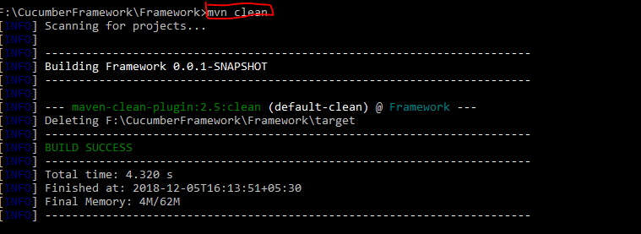

2)mvn test : this will run the test runner file from thhe POM.xml file

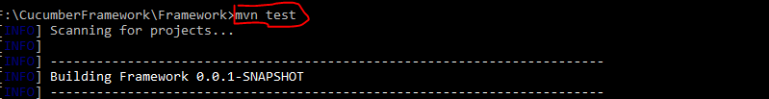

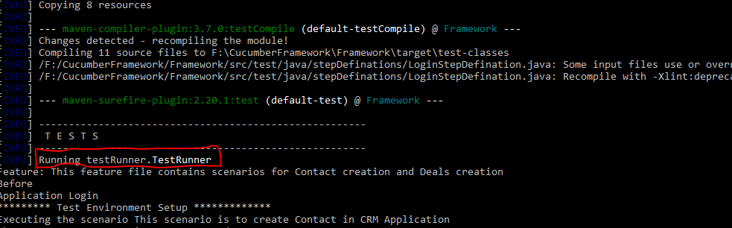

3)To run a scenaro from a command line

***mvn test -Dcucumber.options=”feature file path” + “line number of the scenario”***

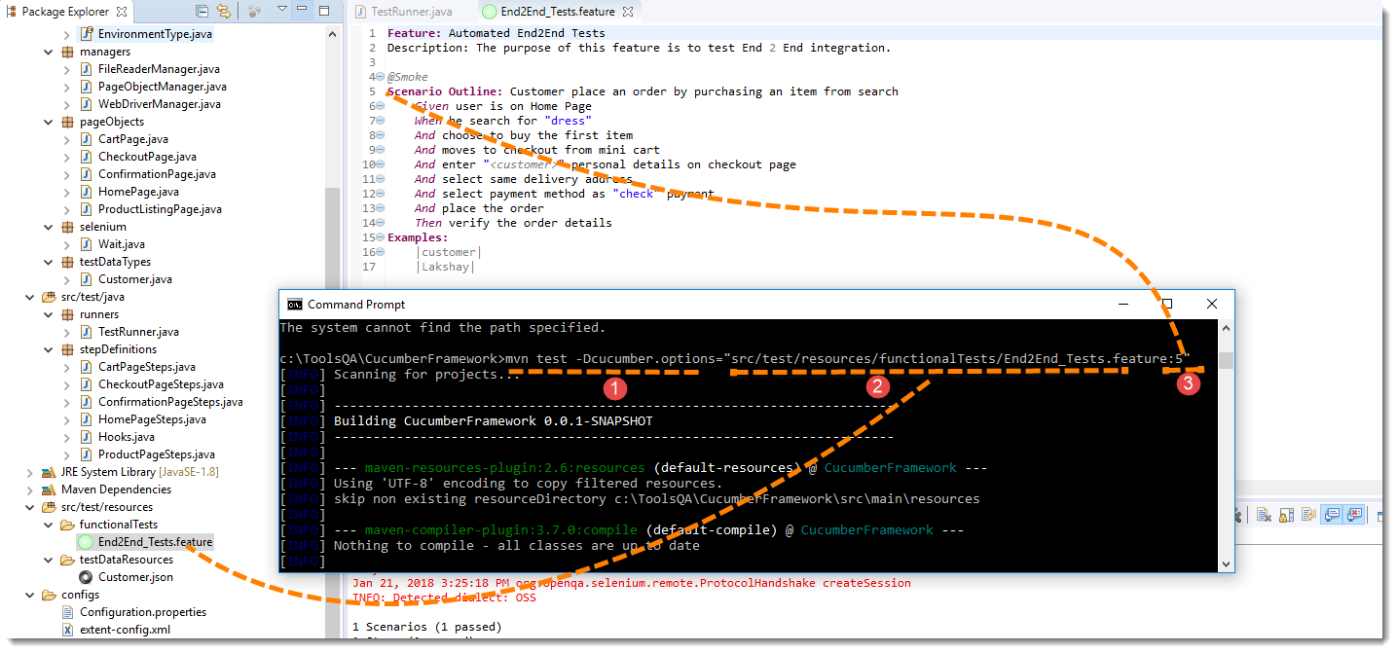

***Note***: In the preceding code, ***“5”*** is the Feature file line number where a Scenario starts.

### 4) Running Scenarios using Tags from Command Line

If you want to run the test cases associated to Tags, this is how we specify :

**mvn test -Dcucumber.options=”–tags @tag Name”**

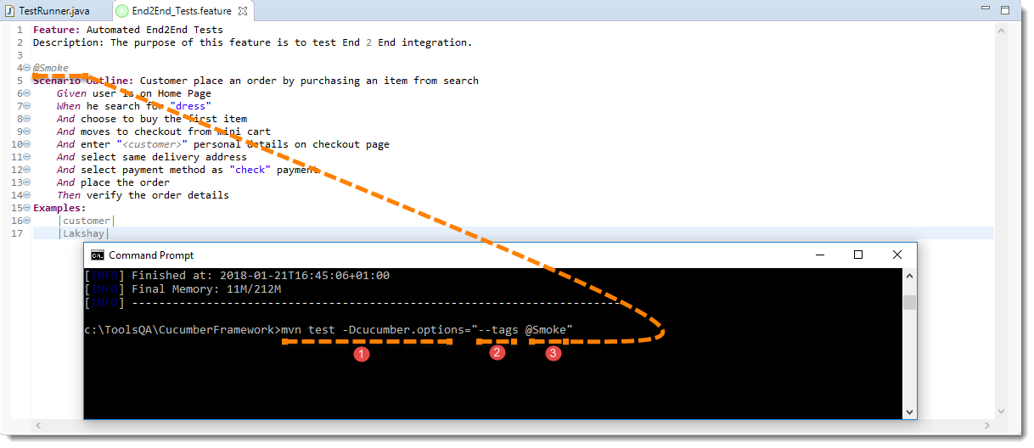

### Overriding Report Plugin and Path

If you want to generate a different report or if you wish to change the report path. This how you do it:

***mvn test -Dcucumber.options=”–plugin junit:target/cucumber-reports/report.xml”.***

Please look at our [Cucumber Report](http://toolsqa.com/selenium-cucumber-framework/cucumber-reports/) to see what all reports you can generate using *@CucumberOptions*.

### Running a Feature file only from Command Line

If you want cucumber to run just a single feature file or multiple feature file, you can pass parameter for the same from command line. This how you do it:

***mvn test -Dcucumber.options=”src/test/resources/functionalTests/End2End_Tests.feature”***

### Passing multiple Parameter at once

Its also possible to pass multiple options at once. This is how it can be done

***mvn test -Dcucumber.options=”SomeThing” -Dcucumber.options=”SomeThing” -Dcucumber.options=”SomeThing”***

***mvn test -Dcucumber.options=”src/test/resources/functionalTests/End2End_Tests.feature”-Dcucumber.options=”–tags @Smoke”***